**a. Pre-Requisite to Install Pig**

You must have [Hadoop](http://data-flair.training/blogs/hadoop-introduction-tutorial-quick-guide/) and Java JDK installed on your system. Hence, before installing Pig you should install Hadoop and Java by [following the steps given in this installation guide](http://data-flair.training/blogs/install-cloudera-hadoop-cdh5-ubuntu/).

**b. Downloading Pig**

You can download Pig file from the below link:

<https://archive.cloudera.com/cdh5/cdh/5/>

hadoop-2.5.0-cdh5.3.2 is already installed on the system hence the supported pig version will be downloaded from here which is pig-0.12.0-cdh5.3.2.

**c. Installing Pig**

The steps for Apache Pig installation are given below:

**Step 1:**

Move the downloaded pig-0.12.0-cdh5.3.2.tar file from Downloads folder to the Directory where you had [installed Hadoop](http://data-flair.training/blogs/setup-hadoop-2-yarn-psedo-distributed-mode/).

**Step 2:**

Untar pig-0.12.0-cdh5.3.2.tar file by executing the below command on your terminal:

dataflair@ubuntu:~$ tar zxvf pig-0.12.0-cdh5.3.2.tar

**Step 3:**

Now we need to configure pig. In order to configure pig, we need to edit “.bashrc” file. To edit this file execute below command:

dataflair@ubuntu:~$ nano .bashrc

And in this file we need to add the following:

1. export PATH=$PATH:/home/dataflair/pig-0.12.0-cdh5.3.2/bin
2. export PIG_HOME=/home/dataflair/pig-0.12.0-cdh5.3.2
3. export PIG_CLASSPATH=$HADOOP_HOME/conf

**[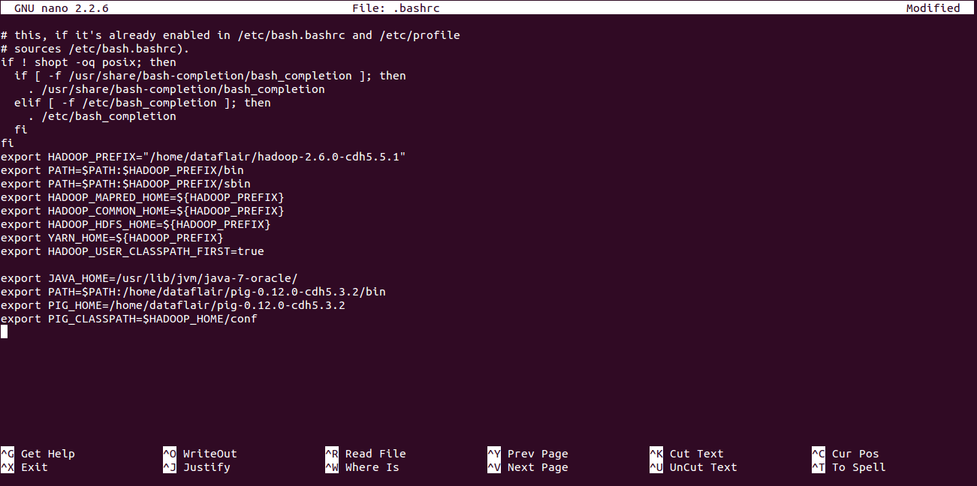](https://d2h0cx97tjks2p.cloudfront.net/blogs/wp-content/uploads/Pig-Installation_Bashrc-File.png)**

After adding the above parameters save this file by using “CTRL+X” and then “Y” on your keyboard.

**Step 4:**

Update .bashrc file by executing below command:

dataflair@ubuntu:~$ source .bashrc

After refreshing the .bashrc file Pig gets successfully installed. In order to check the version of your Pig file execute the below command:

dataflair@ubuntu:~$ pig -version

If the below output appears means you had successfully configured Pig.

**[](https://d2h0cx97tjks2p.cloudfront.net/blogs/wp-content/uploads/Pig-Version.png)**

**d. Starting Pig**

We can start Pig in one of the following two modes mentioned below:

1. Local Mode
2. Cluster Mode

To start using pig in local mode ‘-x local’ option is used whereas while executing only “pig” command without any options, Pig starts in the cluster mode. While running pig in local mode, it can only access files present on the local file system. Whereas, on starting pig in cluster mode pig can access files present in [HDFS](http://data-flair.training/blogs/introduction-tutorial-hdfs/).

To start Pig in Local Mode execute the below command:

dataflair@ubuntu:~$ pig -x local

And if you get the below output that means Pig started successfully in Local mode.

[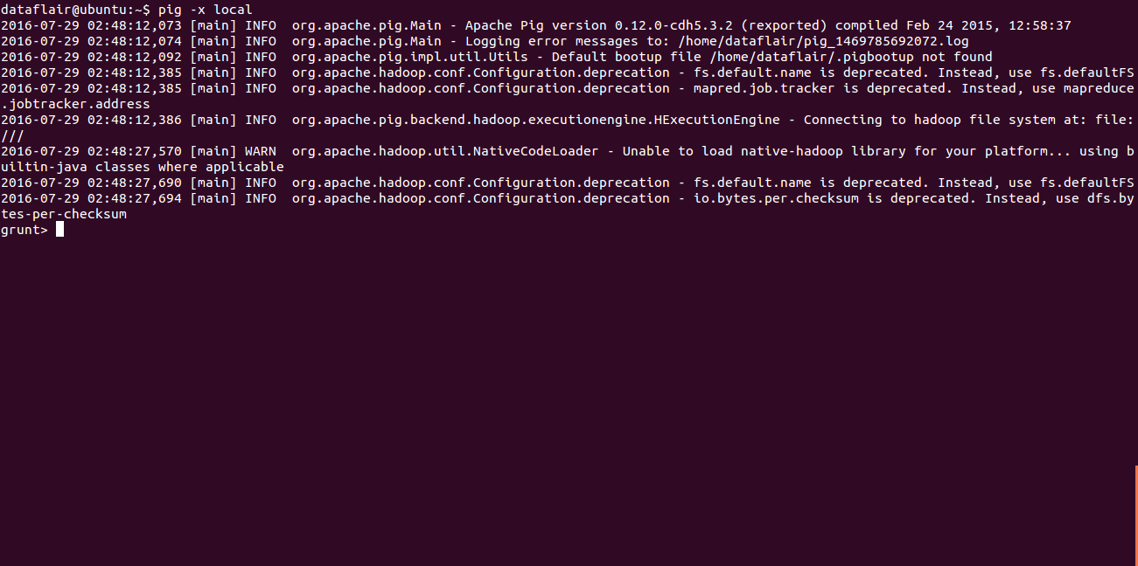](https://d2h0cx97tjks2p.cloudfront.net/blogs/wp-content/uploads/Running_Pig_Local_mode.png)

To start Pig in Cluster-Mode execute the below command:

dataflair@ubuntu:~$ pig

And if you get the below output that means Pig started successfully in Cluster mode.

[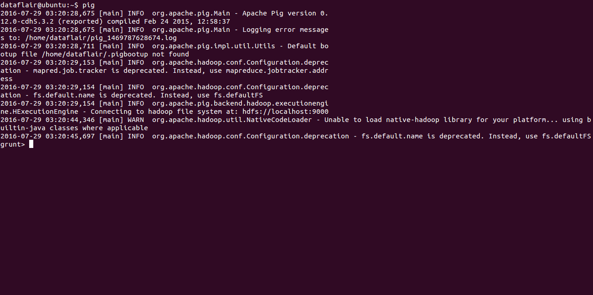](https://d2h0cx97tjks2p.cloudfront.net/blogs/wp-content/uploads/Running_Pig_Cluster_mode.png)